Executive Summary_v3.2 (last update October 29, 2015)

Process
Assessments for all 20 groundfish stocks in the New England Fishery Management Council’s (NEFMC) Multispecies Groundfish Fisheries Management Plan were updated and reviewed during September 14-18, 2015 at the Northeast Fisheries Science Center (NEFSC), Woods Hole, MA (Table 1). This represents the fourth comprehensive assessment of the status of all the groundfish stocks since 2001. The first three comprehensive assessments were produced through the Groundfish Assessment Review Meeting (GARM) process (NEFSC 2002, 2005, 2008). Thirteen of the groundfish stocks were updated through the Operational Assessment process (NEFSC 2012). Operational assessments, first described by the Northeast Regional Coordinating Council NRCC in 2011, rely on decisions of previous benchmarks for model formulation and definition of biological reference points (BRPs). The terms of reference for the operational assessments are provided in Section 22.a <insert prior to Section 22.1>. The efficiency of the Operational Assessment process increases the frequency but reduces the ability to modify model structure either in response to new data or external inputs. Major modifications of the assessment models are restricted to benchmark assessments that can incorporate a much greater range of information but for far fewer stocks. In this context, the scope of admissible changes in the assessment was summarized in a letter from the NRCC (Section 22.1). Of particular note, newly available research resulted in modifications of discard mortality rates applied in several assessments.

On July 22, 2015 the NEFSC held five port-based outreach meetings for fishermen and other stakeholders. These occurred in Maine (Portland), New Hampshire (Hampton), and Massachusetts (Gloucester, Woods Hole, New Bedford.) Assessment analysts met with attendees at each location to learn more about recent observations from the fleet and ports that might help focus future research to improve assessments and interpret patterns in the current assessments. Each meeting started with a brief introduction on the timeline for the assessments, what new information would be considered, and how the results would be reviewed before use in the fishery management process.

These were not the first time outreach meetings have been held for industry ahead of an assessment, but this is the first time that summaries of the outreach meetings are included in the assessment report and provided to peer reviewers ahead of their review meeting. The summaries were prepared from notes taken by NEFSC communications staff, and then provided to meeting attendees for comment before they were finalized for publication. See Section 22.3 for details. A formal statement from a fishing industry member was made available at the meeting and is provided in Section 22.4.

The NRCC guidance was taken into consideration by the Assessment Oversight Panel which reviewed the plans for each assessment prepared by the individual analysts. See Section 22.2 for a summary of their July 27, 2015 meeting. Given the relatively new process associated with these operational assessments, the NEFSC made an extra effort to promote understanding of the process ahead of the peer review meeting. These efforts included a webinar/seminar for in-house outreach staff, sector managers, and New England fishery Management Council groundfish and recreational fishing advisors on July 20, and a data-rich dedicated website: http://www.nefsc.noaa.gov/groundfish/operational-assessments-2015/

The Peer Review Panel (i.e., Panel) consisted of the following individuals:

- Steven X Cadrin, (chair) School for Marine Science and Technology, University of Massachusetts, N. Dartmouth, MA, NEFMC Scientific and Statistical Committee
- Jean-Jacques Maguire, NEFMC Scientific and Statistical Committee
- Gary Nelson, Massachusetts Division of Marine Fisheries, Gloucester MA
- James Berkson, NOAA Sea Grant, Silver Spring, MD.

The Panel was responsible for reviewing each of the stock assessments. Primary and supporting documents for each assessment were available prior to the meeting. Each lead assessment scientists (Table 2) prepared a short presentation to describe the assessment results and address key sources of uncertainty (See agenda). Following the presentation the Panel was responsible for addressing four topics:

- Accept/ Not Accept assessment as a basis for setting Overfishing Limit (OFL)
- If assessment not accepted then recommend alternative basis for setting OFL
- Identify key sources of uncertainty
- Identify important research needs

If an assessment was not considered suitable for estimation of OFL the Panel was responsible for approving an alternative basis such as some function of recent average catch.

The individual assessment sections within this report are standardized and designed to capture the most relevant information for reviewers and fishery managers. The report structure was developed with and approved by a subcommittee of the NRCC, followed by NRCC review of the report structure. Each assessment is supported by an online set of companion tables, figures and maps which provide major users of the assessment information (e.g., Plan Development Teams, Science and Statistical Committee) with necessary details. The online data portal (http://www.nefsc.noaa.gov/saw/sasi/sasi_report_options.php)also contains model inputs and outputs that can be used directly in the NOAA Fisheries Toolbox (http://nft.nefsc.noaa.gov/ ) applications.

The meeting was broadcast as a webinar using Adobe Connect and all sessions were open to the public. The meeting agenda included a daily public comment period. Members of the audience and individuals on the phone were included in the discussions of the panel. However, the tight timeline for completing the assessments required a strong adherence to the terms of reference and guidance from the NRCC. Onsite participants in Woods Hole are listed in Section xx. <<to add>>

Data
The groundfish updates used the following standard procedures for updating data from landings, discards and surveys (Table 3). The US commercial landings are estimated by market category from the area allocation (“AA”) tables which combine dealer and vessel trip reports to determine where fish were caught. The US commercial discards are estimated by gear types using the Standardized Bycatch Reporting Methodology (SBRM) which combine observer data (including at-sea monitors) and dealer landings. The US recreational landings and discards come from the Marine Recreational Information Program (MRIP) including recent revisions to historical data. Both commercial and recreational discards have species-specific discard mortality rates applied to the discarded fish. Catch-at-age is estimated using age-length keys applied to expanded length frequency distributions. For white hake, which is landed headed, the age-length key is applied to predicted lengths based on dorsal fin to caudal fin length. Additional sources of catch for some species come from Canadian or other foreign fishing.
The NEFSC spring and fall bottom trawl surveys are the most common source of information for population trends (Table 3). These surveys are calibrated to Albatross units in most cases to allow for the longest time series possible. NOAA ship Henry B. Bigelow replaced the Albatross IV as the primary bottom trawl survey vessel in spring 2009. In some instances the calibration coefficient varies by length but in others a simple scalar adjustment is applied to all length classes. Other surveys used include the Massachusetts Division of Marine Fisheries spring and fall bottom trawl surveys, the Maine-New Hampshire spring and fall bottom trawl surveys, the Canadian Department of Fisheries and Oceans February survey, and some additional state surveys. Catch per unit effort is not typically used as a source of population trends due to the many regulatory changes that have occurred over time in the Northeast. All updated assessments used a consistent quality assurance criterion (known as TOGA refxx??) for surveys conducted by the NOAA ship Henry B. Bigelow
Models
Based on previous benchmark assessments (Table 4) there are thirteen stocks assessed with an age-based approach. Eight use the statistical catch at age model ASAP while the other five use virtual population analysis (VPA). The stock assessments using ASAP were all configured to not include the likelihood constants due to a potential bias associated with the 'Use Likelihood Constants' option, as agreed by both the AOP and Review Panel. For the five VPA stocks, the 2015 spring survey information was included in the model. The remaining seven stocks are assessed with a range of model types including surplus production, length-based (SCALE), index (AIM), and direct survey expansion. The reference points for the age- and length-based assessments were derived from stochastic projections of the F_{MSY} (or F_{MSY} proxy) for many years (typically 100) while the other assessment types use stock-specific rules for deriving the reference points.

Results

Operational Assessments were conducted in 2015 for the twenty stocks in the Northeast Multispecies Fishery Management Plan (Table 1). The updates replicated the methods recommended in the most recent benchmark decisions, as modified by any subsequent operational assessments or updates (Table 2). Information supplemental to the assessment report for each stock can found on the Stock Assessment Support Information (SASINF) website. The Review Panel accepted 18 of the 20 assessments as a scientific basis for management and provided estimates of overfishing limits (OFLs) for all 20 stocks. The two stock assessments which were not accepted as a basis for setting OFLs were Georges Bank cod and Atlantic Halibut. Stock status did not change for 15 of the 20 stocks, worsened for two stocks, improved for one stock, and became more uncertain for two stocks (Table 5).

Each of the 20 species chapters contains the assessment results provided to the Panel for peer review followed by a section entitled “Reviewer Comments”, which describes final Panel decisions at the conclusion of the peer review. For most of the stocks, the assessment results and the “Reviewer Comments” are consistent with each other. However, for those stock assessments that were not accepted by the Panel (e.g., Georges Bank cod and Atlantic halibut), the “Reviewer Comments” pertaining to stock status differ from those in the “State of Stock” and “Special Comments” sections of those chapters which were written prior to the peer review. Although the Panel agreed to include these two assessments in this report as one interpretation of the available information, it is important to note that in these cases the Panel drew different conclusions about stock status and about the appropriate basis for catch advice. In the Executive Summary, tables and figures related to stock status reflect the Panel decisions. Specifically, for both Georges Bank cod and Atlantic halibut overfishing is described as unknown and both stocks are described as overfished (Table 5). Furthermore, for these two stocks, estimates from the updated assessment models are not provided (Table 8; Figure 2; Figure 3).
The number of stocks with retrospective adjustments (also called rho adjustments) applied increased from the last assessment from 2 to 7 (Table 6). The previous Georges Bank cod assessment did apply a retrospective adjustment, however, the assessment model was not accepted at the 2015 Operational Assessment so it has been excluded from these counts. Decisions to apply a retrospective adjustment to estimates of terminal year biomass and fishing mortality rates were based on several considerations. A primary consideration was whether the rho- adjusted value was outside the joint confidence region for the model estimates. This principle was applied to adjust biomass estimates for Georges Bank haddock, Cape Cod/Gulf of Maine yellowtail flounder, Georges Bank winter flounder, American plaice and redfish (Table 7). This principle was not applied to Gulf of Maine cod because of earlier guidance from the SARC 55 review panel. Despite the presence of a significant retrospective pattern at that meeting no adjustments were made; the review panel for the Operational Assessments followed that precedent. Biomass and F estimates for 2014 for Southern New England/Mid-Atlantic yellowtail flounder also fell outside the joint confidence region. The Review Panel did not suggest application of the rho adjustment in this case because the majority of the rho-adjusted biomass estimates of biomass were insufficient to support the projected catches in 2015. This reduced the reliability of those biomass estimates as a basis for estimating OFL in 2016. Finally, the 2014 biomass estimate for pollock was inside the confidence interval but the fishing mortality estimate exceeded the upper bound of the model based confidence interval. A retrospective adjustment was therefore applied.

Stock status for the 20 groundfish stocks is summarized in Table 8. While the number of overfished stocks and stocks experiencing overfishing has generally decreased since 2007 (Fig. 1), the magnitude of overfishing or depletion for several stocks has worsened considerably (Fig. 2 and 3); Gulf of Maine cod, Southern New England/Mid-Atlantic yellowtail flounder, witch flounder and Cape Cod/Gulf of Maine yellowtail flounder). Of those Northeast groundfish stocks for which stock status can be determined, the majority remain below their biomass targets (69%; Fig. 1 and 3).

Simultaneous assessment of all 20 groundfish stocks allowed a comprehensive examination of trends in survey indices. Recent NEFSC survey biomass indices for both the spring and fall surveys are below the long term means (Figures 4 and 5, respectively). For the majority of stocks the average of the most recent five years is below the time series means.

Estimates of overall (aggregate) groundfish minimum swept area biomass are at, or near, an all-time high (Fig. 6 and 7). However, the current stock diversity of the overall groundfish biomass is less than that seen in the 1960s and 1970s. Current groundfish biomass is dominated by only a few stocks: For example the combined biomass of the Georges Bank haddock, Gulf of Maine haddock, and redfish stocks currently constitute more than 80% of the overall groundfish biomass observed in the surveys (Figure 8). It is important to note that the minimum swept area biomass estimates assume a common capture efficiency of 1.0 across all years. Actual biomasses, as derived from models, are adjusted for catchability and selectivity estimates and are higher than the swept area estimates. Unfortunately model-based estimates are not available for all stocks over the entire time period of the surveys (ie. since 1963); the primary limitation is the availability of age information from the commercial catches that would be needed to support full age-based assessments.

For 13 stocks model-based biomass estimates can be computed for 1985 onward. The striking increase in abundance since 1985 is driven primarily by redfish, Georges Bank haddock, and pollock (Fig. 8). Pollock biomass from the stock assessment is much higher than the swept area estimates because of a dome-shaped selectivity pattern in both the survey and catch data. This suggests that a large fraction of the stock biomass is unavailable to either the fishery or survey gear. Traditional methods are not able to confirm or deny this assertion so caution was suggested by the Review Panel. Nonetheless, the increase in model based estimates of overall biomass is consistent with the trends revealed in the swept area estimates (Fig. 6 and 7).

The rapid increase in haddock, redfish, pollock and white hake contrasts sharply with the decline of cod and the flatfish species (Figure 9). Total biomass of haddock, redfish, pollock and white hake have increased from less than 200 kt in 1994 to nearly 900 kt in 2014. Cod and the flatfish stocks have declined from about 140 kt to about 40kt over the same period. Underlying causes for the decline are not known but fishing mortality, poor recruitment, and ecosystem changes are possible causes. The widely differing responses of haddock and cod, species with similar habitats and patterns of co-occurrence are especially worthy of study. One important contrast is that haddock age composition has gradually rebuilt following the imposition of management restrictions in 1994 and a series of strong to very strong year classes have led to rapid increases in spawning stock biomass. In contrast, cod which exhibits less extreme variations in recruitment, did not have a rapid increase in spawning stock biomass nor has it increased following strong year classes. The efficacy of the closure areas on Georges Bank as protective measures seem to have differed between cod and haddock.

An advantage of conducting multiple assessments simultaneously is that measures of productivity can be compared over time. Reductions in average weight-at-age, declines in recruitment and shifts in age-at-maturity all influence the estimated biomass at maximum sustainable yield and total MSY. As such the single species stock assessments provide valuable measures of ecosystem productivity, irrespective of the underlying environmental or ecological causes. Reductions in average weights-at-age have occurred for stocks at high abundance, such as Georges Bank haddock, but also for stocks at low abundance such as witch flounder. Hence density dependence alone is insufficient to explain this. Reductions in recruitment are often associated with declines in stock size but inter-annual variation often masks trends. Aggregate estimates of total B_{MSY} are available for 10 stocks over the past decade (Fig. 10). Total B_{MSY} for these stocks declined by 12% between 2005 and 2008 from 760 kt to 668 kt. Estimates further declined by 21% between 2008 and 2015 to 525 kt (Fig 10).

Table 2. Comparison of biomass and fishing mortality rate Mohn’s rho values by stock between previous assessment and the 2015 updates. The biomass and fishing mortality rate point estimates and rho adjusted values are provided for the 2015 update assessments. The total number of stocks using rho adjusted values in the last assessment and the 2015 assessments, along with the type of rho adjustment used in the 2015 assessment (NAA=numbers at age, SSB=spawning stock biomass applied to all ages), are also provided. Only age-based and length-based stocks that could exhibit retrospective patterns are included in this table. Note: Because the Georges Bank cod assessment was rejected at the 2015 OA Update it has been excluded from this table.

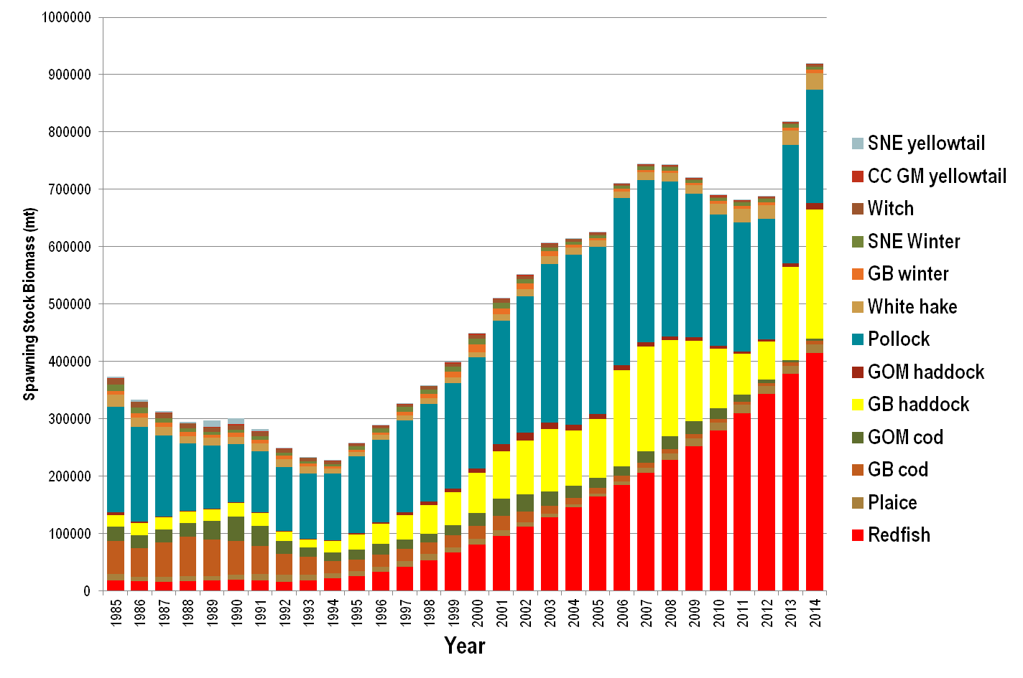

Figure 8. Model-based spawning stock biomass estimates for 13 groundfish stocks, 1985-2014 based on the Operational Assessments in 2015. The Georges Bank cod model estimates were not used for management advice due to a strong retrospective pattern in recent years.
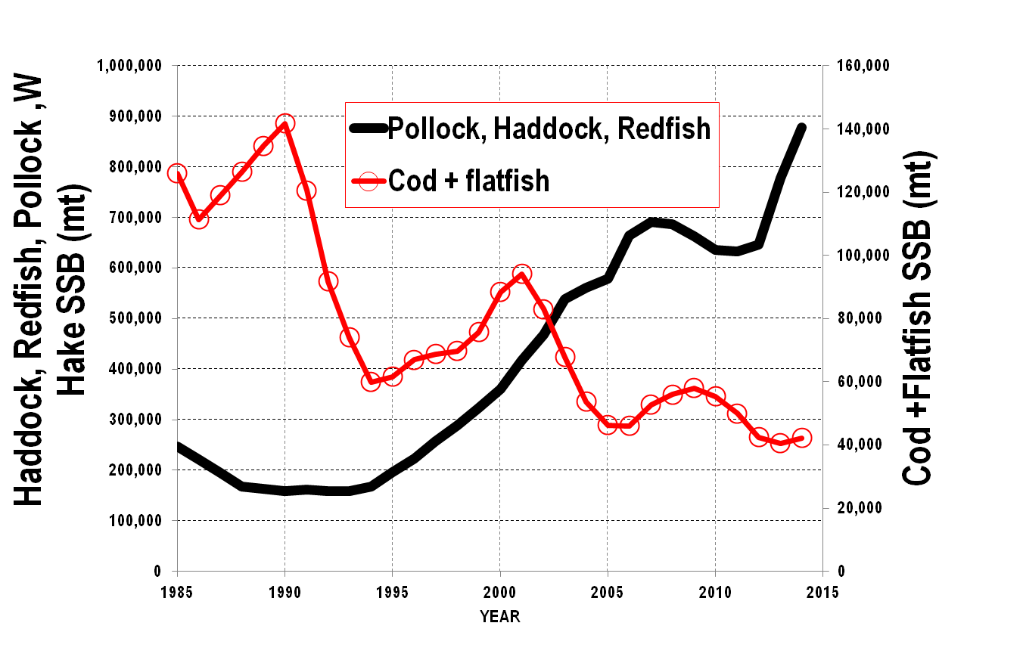
Figure 9. Contrasting biomass trends for Georges Bank and Gulf of Maine haddock, redfish, Pollock, and white hake (thick solid line, left axis) versus Georges Bank and Gulf of Maine cod, Georges Bank and Southern New England winter flounder, Southern New England and Cape Cod/Gulf of Maine yellowtail flounder, witch flounder, and American plaice (solid line, open circles, right axis). The Georges Bank cod model estimates were not used for management advice due to a strong retrospective pattern in recent years.

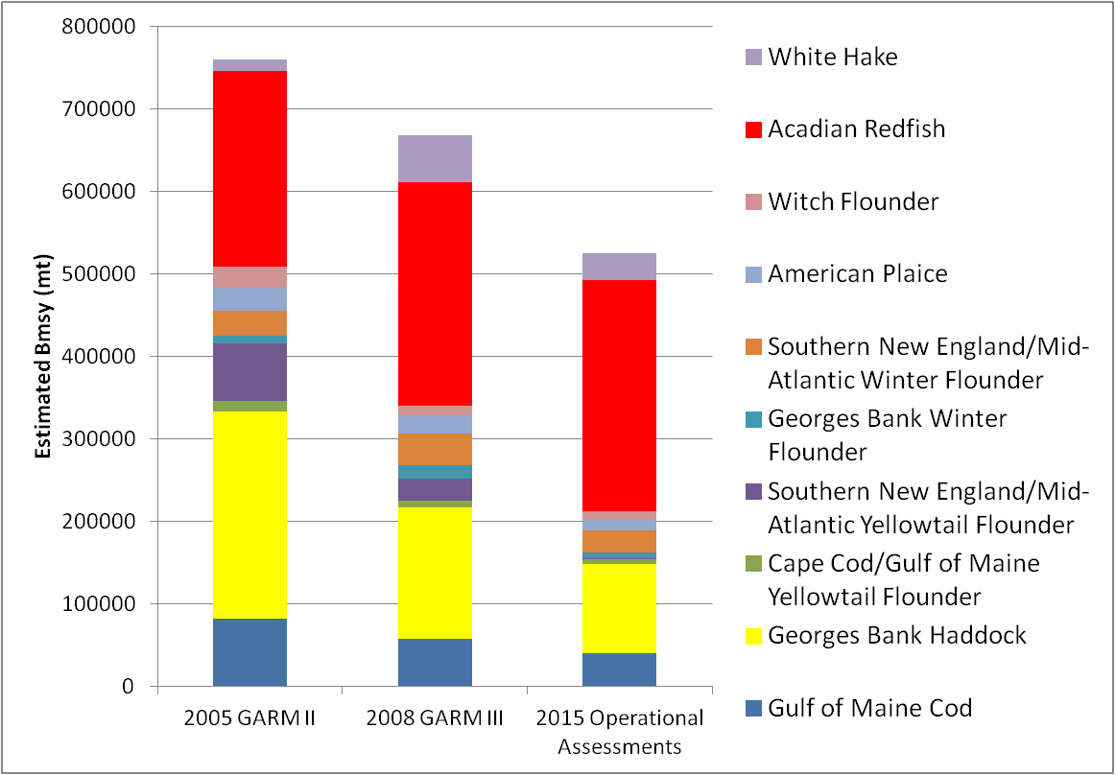

Figure 10. Sum of B_{MSY} estimates for ten stocks which had B_{MSY} estimates in 2005 (759,950 mt), 2008 (667,713 mt) and 2015 (525,496 mt) assessments. The following stocks were excluded: Gulf of Maine haddock are excluded because B_{MSY} estimates were not derived until GARM III. Pollock is not included since biomass targets not established until 2010 at SARC 50. B_{MSY} estimates for Gulf of Maine winter flounder and Georges Bank yellowtail flounder are not available as both stock assessments are based on swept area expansions. The assessment model for Georges Bank cod was not accepted for catch advice in 2015.

